

DARSHAN ACADEMY, MEERUT
Sawan Ashram, West End Road, Meerut

A Practical Record File
is submitted for the partial fulfilment of
AISSCE Examination 2024-25



Under the guidance of Gopal Singh (PGT - Computer)

Submitted By: Omkaar

Roll Number: 21716376

TABLE OF CONTENTS
S. No. | Assignment | Page No.
Programs using Pandas
SERIES
1 | Creating a Python program to create a series using a dictionary | 3
2 | Creating a Python program to create a series using scalar value | 4
3 | Creating a Python program to create a series using NumPy array | 5
4 | Creating a python program for modifying or updating existing values of series object | 6
5 | Creating a Python program for performing mathematical operations on two Series objects | 8
6 | Creating a Python program for calculating per capita income of four zones using Series | 10
7 | Creating a Python program to display attributes of a Series | 11
8 | Creating a Python program using head() and tail() in Series | 12
DATAFRAME
9 | Creating a Python program for creating a DataFrame using a nested list | 13
10 | Creating a python program for accessing values of rows and columns of a dataframe. | 14
11 | Creating a Python program for accessing values of rows and columns of a dataframe. | 16
12 | Creating a python program to perform operations on a DataFrame (rename, count, update, replace) | 17
13 | Creating a Python program to filter the data of a DataFrame | 19
14 | Creating a Python program to display the attributes of the DataFrame | 20
15 | Creating a Python program to display the data of a DataFrame row-wise and column-wise using iterrows() and iteritems() | 22
16 | Creating a Python program to perform writing and reading operations in a CSV file | 25
Programs using Matplotlib – Data Visualization
17 | Creating a python program for plotting a line chart | 26
18 | Creating a python program for plotting a bar chart from a CSV file | 27
19 | Creating a python program for plotting a multiple bar chart from a CSV file | 28
20 | Creating a python program for plotting Histogram | 29
SQL Queries
21 | SQL COMMANDS EXERCISE – 1 (Basic Queries – I) | 30
22 | SQL COMMANDS EXERCISE – 2 (Basic Queries – II) | 32
23 | SQL COMMANDS EXERCISE – 3 (Aggregate functions, Order by Group by, Having Clause) | 33
24 | SQL COMMANDS EXERCISE – 4 (Math Functions) | 34
25 | SQL COMMANDS EXERCISE – 5 (Text Functions) | 35
26 | SQL COMMANDS EXERCISE – 6 (Date Functions) | 36

1) To write a Python program to create a Series to store 5 students Percentage Using dictionary and print all the elements that are above 75 percentage.

Source Code:

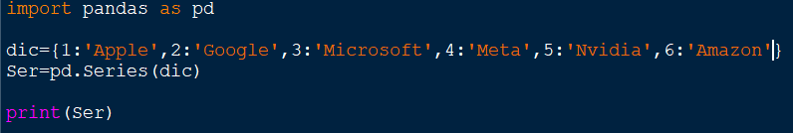

Output:

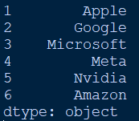

2) To write a Python program to create a Series object that stores the Initial budget
allocated (50000/- each) for the four quarters of the year: Qtr1, Qtr2, Qtr3 and Qtr4.

Source Code:

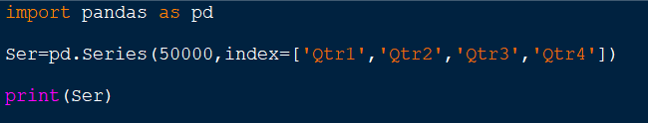

Output:
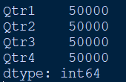

3) To write a Python program to create a Series object that stores the Employee names as index and their Salary as values.

Source Code:
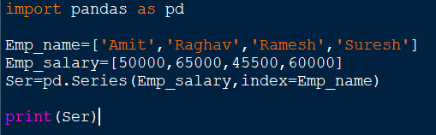

Output:
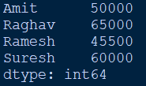

4) To Write a Python program to create a Series object with Employee names as the index and their salaries as values. Accept the name of the employee whose salary needs to be changed, along with the new salary, and update it in the Series.

Source Code:
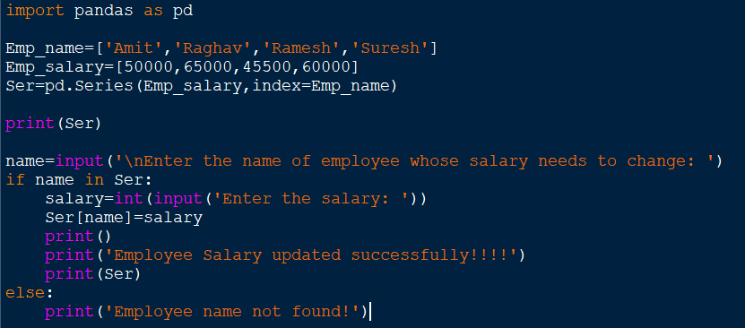

Output:
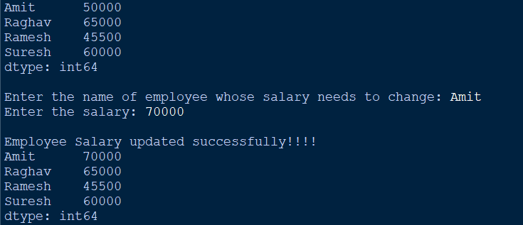

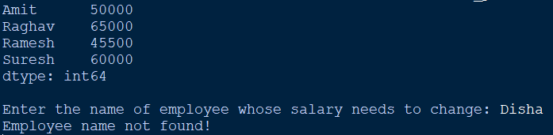

5) To create two series S1 and S2, to perform following mathematical Operations on Two Series objects:
(i) Addition (ii) Subtraction (iii) Multiplication (iv) Division Also show the result.

Source Code:

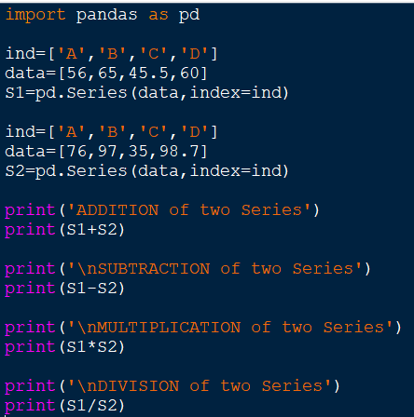

Output:

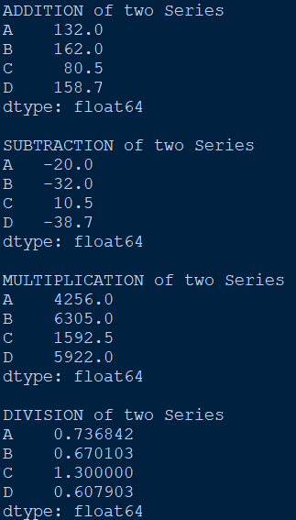

6) To write a Python program to create two series i.e. population and average income of Four Zones, and then calculate per capita income storing in third pandas series print it.

Source Code:
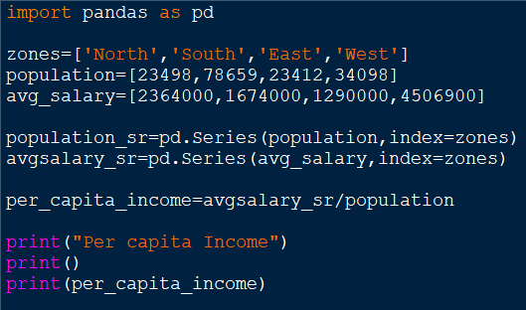

Output:
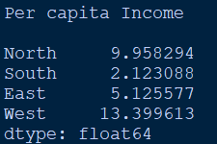

7) To write a Python program to create a Series using list and display the following
attributes of the Series: (i) index (ii) dtype (iii) size (iv) shape (v) hasnans

Source Code:

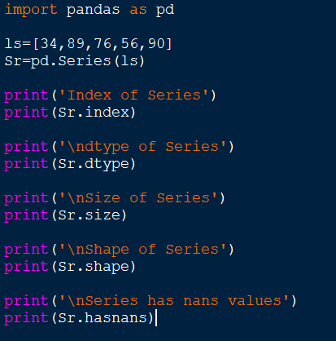

Output:
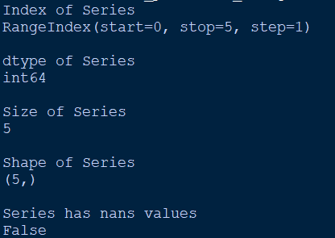

8) To write a Python program to create a Series using list of Marks of 10 students and
display first 5 Students’ marks and Last 2 Students’ marks from Series object.

Source Code:
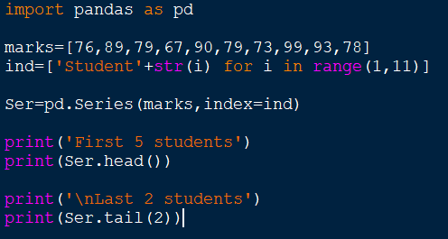

Output:

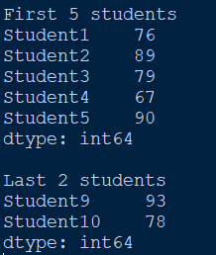

9) To write a Python program to create a panda’s Data Frame for the following table Using Nested list:

Source Code:
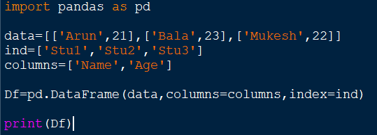

Output:
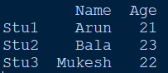

10) To write a Python program to create a panda’s DataFrame called DF for the following table Using Dictionary of List and perform the following operations:

(i) To Display only column 'Toys' from DataFrame DF.
(ii) To Display the row details of 'AP' and 'OD' from DataFrame DF.
(iii) To Display the column 'Books' and 'Uniform' for 'M.P' and 'U.P' from DataFrame DF.
(iv) To Display consecutive 3 rows and 3 columns from DataFrame DF.

Source Code:

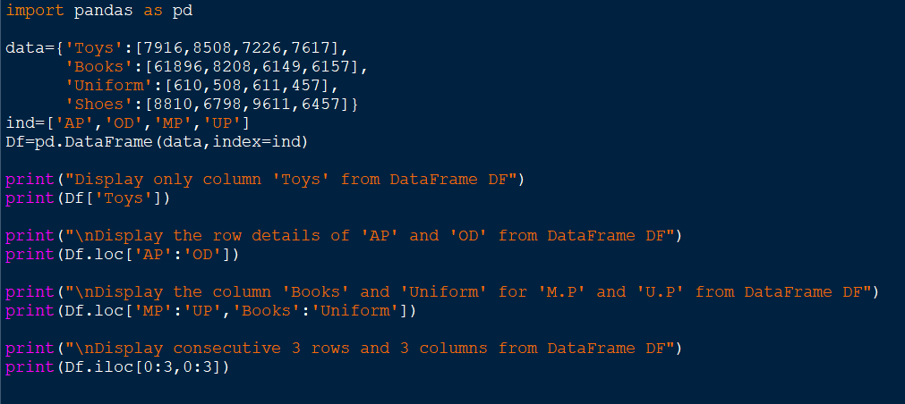

Output:

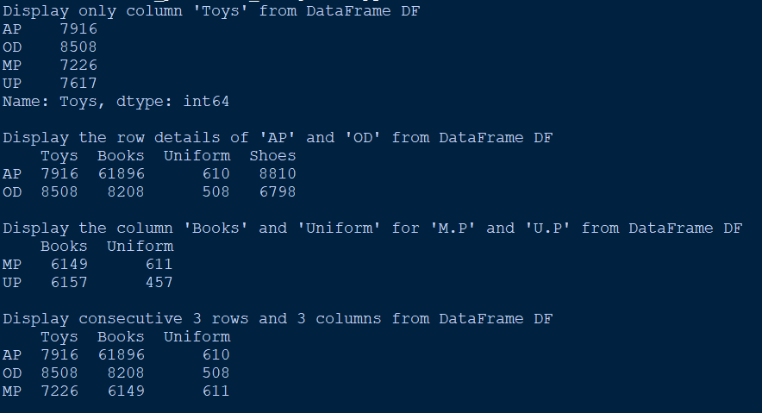

11) To write a Python program to create a panda’s DataFrame called DF for the following table Using Dictionary of List and perform the following operations:

(i) Insert a new column “Bags” with values as [5891, 8628, 9785, 4475].
(ii) Delete the row details of M.P from DataFrame DF.

Source Code:
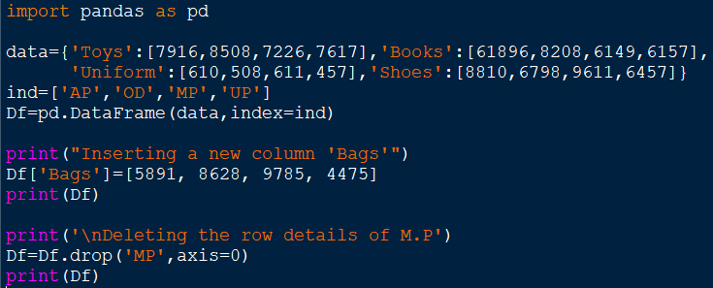
Output:
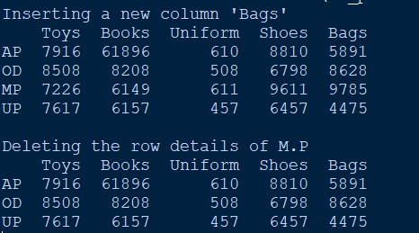

12) To write a Python program to create a pandas DataFrame to analyze number of
Government and Private medical college and their Total seats, Fees statewise details
using the dataset available at www.data.gov.in. Also, perform the following
operations.
(i) To Change the name of the state AP to Andhra.
(ii) To Count and Display Non-NaN values of each column.
(iii) To Count and Display Non-NaN values of each row.
(iv) To Increase the fees of all colleges by 5%
(v) To Replace all NaN values with 0.

Source Code:
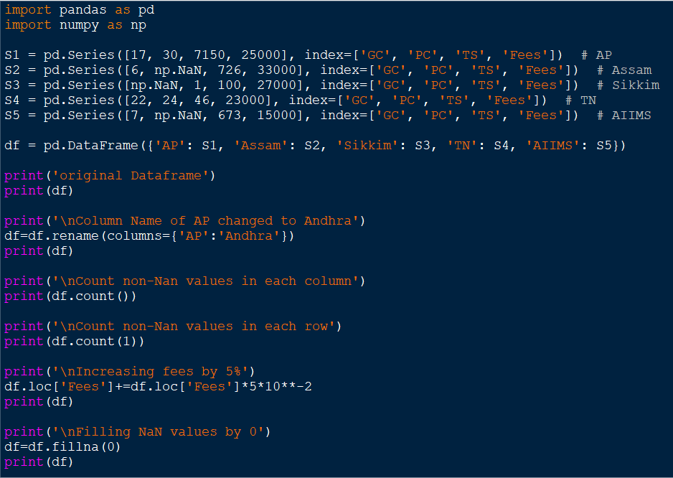

Output:
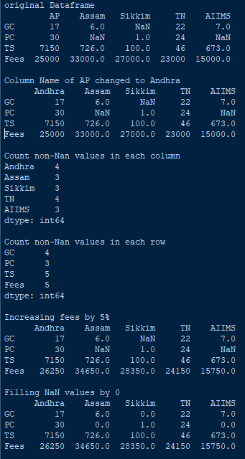

13) To write a Python program to create a panda’s DataFrame called DF for the following table using Dictionary of List and display the details of students whose Percentage is more than 85.

Source Code:
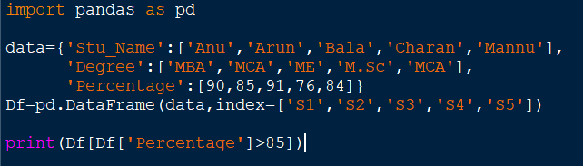

Output:
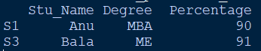

14) To write a Python program to create a DataFrame using Dictionary of list and display the following attributes of the DataFrame: (i) index (ii) columns (iii) axes (iv) dtypes (v) shape (vi) dimension (vii) T

Source Code:
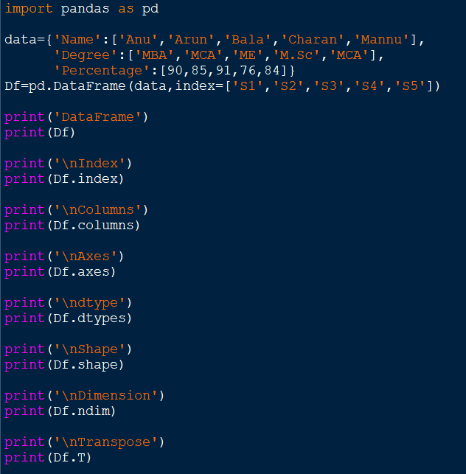

Output:
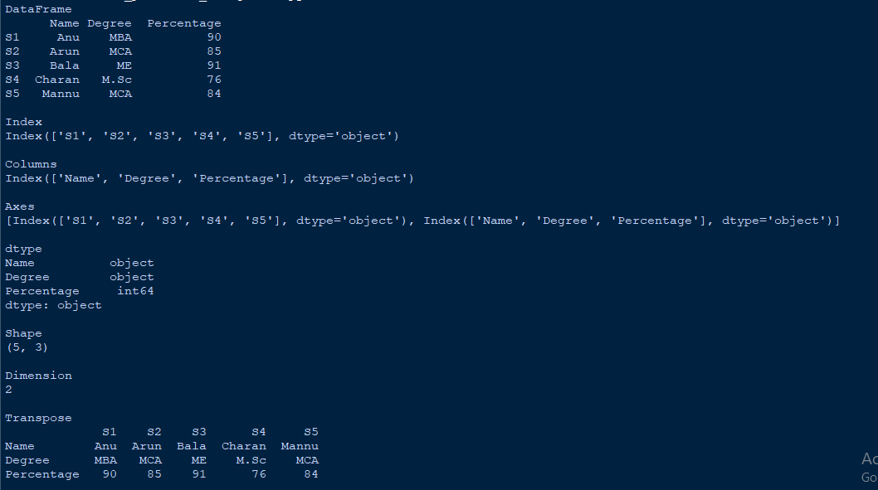

15) To write a Python program to create a panda’s DataFrame called Students for the
following table and demonstrate iterrows and iteritems.

Source Code:

iteritems:
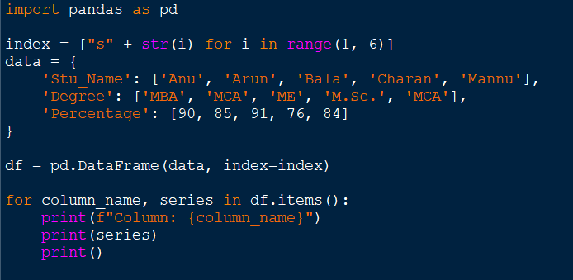

iterrows:
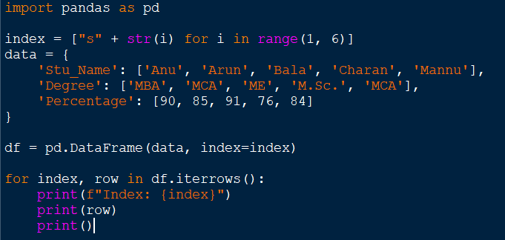

Output:
iteritems:
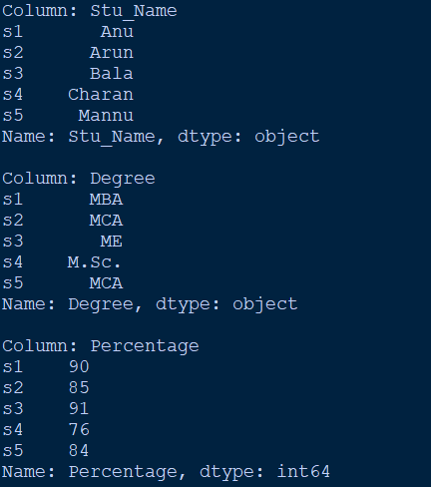

iterrows:
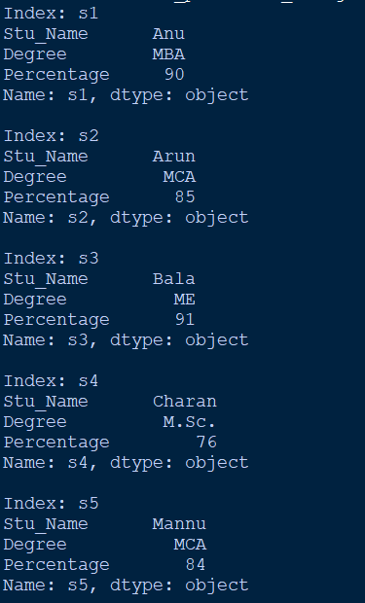

16) To Write a Python program to store the details of Employess’ such as Empno, Name, Salary into a Employee.csv file. Also, write a code to read employee details from csv file.

Source Code:

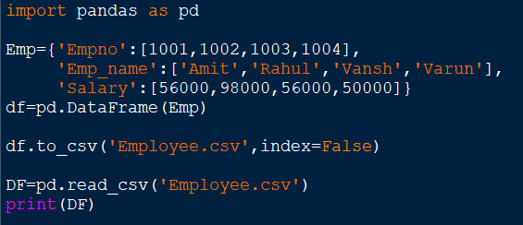

Output:

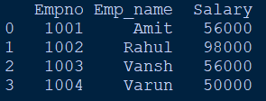

17) To write a Python program to plot a Line chart to depict the changing weekly Onion and Brinjal prices for four weeks. Also, give appropriate axes labels, title and keep marker style as Diamond and marker edge color as ‘red’ for Onion

Source Code:
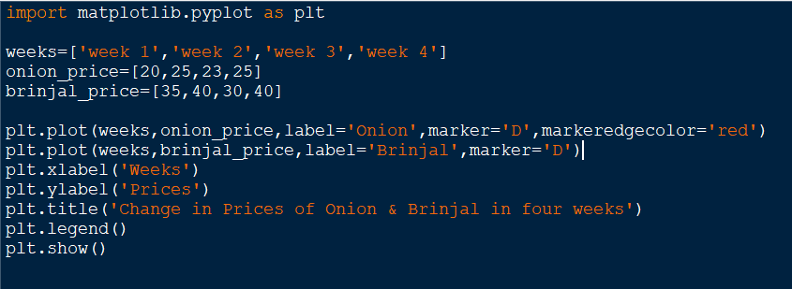
Output:

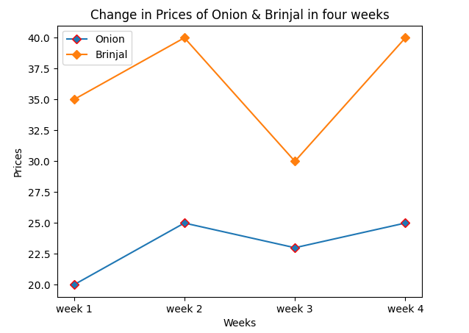

18) To write a Python program to create a DataFrame for subject-wise average, save it to a CSV file, and then draw a bar chart using Matplotlib with a width of each bar as 0.25, specifying different colors for each bar. Additionally, provide a proper title and axes labels for the bar chart.

Source Code:
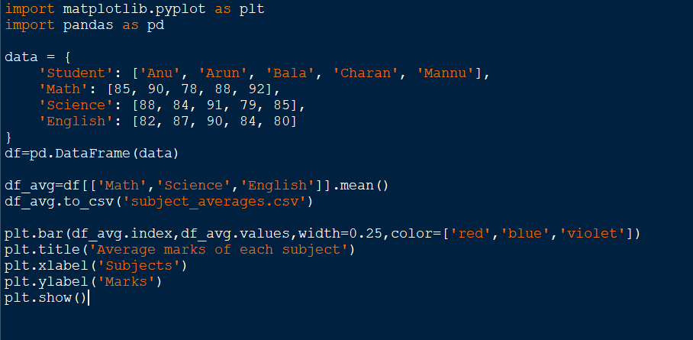
Output:
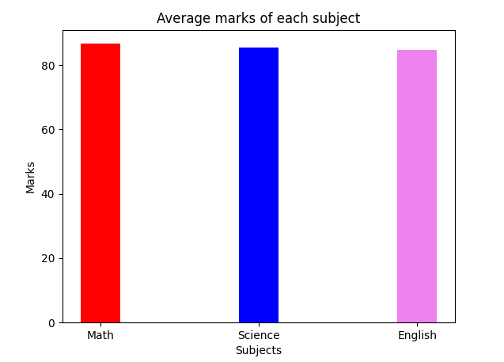

19) To write a Python program to plot a multiple bar chart From CSV file using Matplotlib for subject wise Scores of Class A, Class B, and Class C. Different colors represent each class, and subjects include English, Accountancy, Economics, BST and IP. Proper labels, a title and a legend are displayed on the chart.

Source Code:
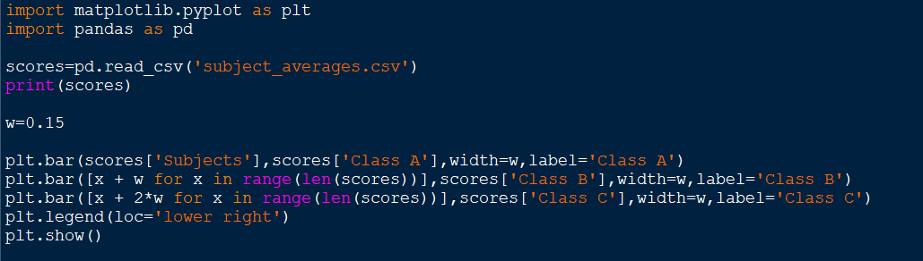
Output:

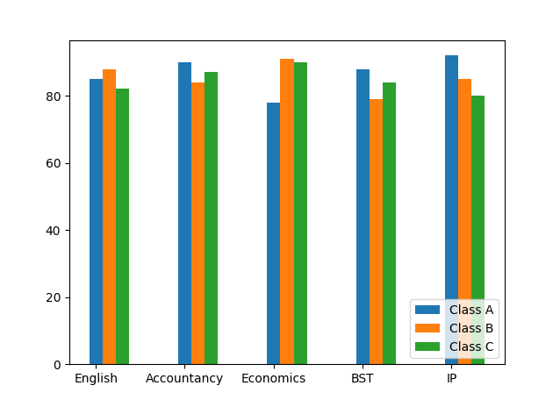

20) To write a Python program to plot a Histogram for the following class interval or
range. Also, give appropriate axes name, title and edege color as ‘red’.

Source Code:
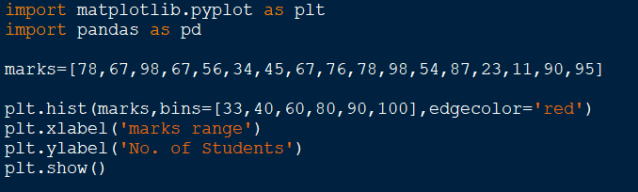

Output:

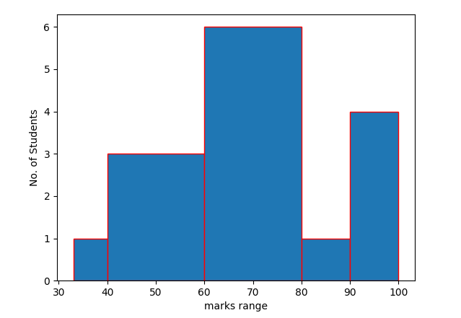

SQL COMMANDS EXERCISE – 1
21) To write Queries for the following Questions based on the given table:

- Write a Query to Create a new database in the name of "EMPS".
- Write a Query to Open the database EMPS.
- Write a Query to create the above table called: Info
- Write a Query to list all the existing database names
- Write a Query to List all the tables that exists in the current database.
- Write a Query to insert all the rows of above table into Info table.
- Write a Query to display all the details of the Employees from the above table 'INFO'.

Queries:
- CREATE DATABASE EMPS;
- use EMPS;
- CREATE TABLE Info
(EmpID INT(8) PRIMARY KEY,
Name varchar(20) NOT NULL,
Gender char(1),
Dept varchar(20),
DOJ Date,
Salary DECIMAL(10, 2) ,
City varchar(10));
- SHOW DATABASES;
- SHOW TABLES;
- Insert into Info(EmpID,Name,Gender,Dept,DOJ,Salary,City)
Values
(1, 'Praveen', 'M', 25, 'Sales', '1989-06-08', 20000, 'Chennai'), (
(2, 'Arun', 'M', 29, 'Marketing', '1989-09-26', 22000, 'Chennai'),
(3, 'Usha', 'F', 27, 'Finance', '1994-08-09', 25000, 'Bangalore'),
(4, 'Bala', 'M', 31, 'Sales', '1990-03-23', 27000, NULL),
(5, 'Rani', 'F', 28, 'Marketing', '1990-04-23', 27000, 'Mumbai'),
(6, 'Nisha', 'F', 26, NULL, '1991-02-24', 18000, 'Bangalore'),
(7, 'Manoj', 'M', 32, 'Finance', '1982-05-06', 30000, 'Goa');
- SELECT * from Info;

SQL COMMANDS EXERCISE – 2
22) To write Queries for the following Questions based on the given table:

- Write a Query to Display Employees’ name and City from the above table.
- Write a Query to Display all details of Employees who are living in Chennai.
- Write a Query to get the name and salary of the employee whose salary is above15000 and gender is not male.
- Write a query to update increase 10% Salary of an employee whose City is 'CHENNAI' and Gender is 'MALE'.
- Write a Query to delete the details of Employee Id 6.

- SELECT Name, City FROM Info;
- SELECT * FROM Info WHERE City = 'Chennai';
- SELECT Name, Salary FROM Info WHERE Salary > 15000 AND Gender != 'M';
- UPDATE Info
SET Salary = Salary * 1.10
WHERE City = 'Chennai' AND Gender = 'M';
- DELETE FROM Info WHERE EmpID = 6;

SQL COMMANDS EXERCISE – 3
(Aggregate Functions, Order By, Group By, Having Clause)
23) To write Queries for the following Questions based on the given table:

- Write a Query to list names of Employees in Descending order.
- Write a Query to find a total salary of all employees.
- Write a Query to display maximum salary and minimum salary of employees.
- Write a Query to count the number of employees earning more than 25000.
- Write a query to display sum of salary of the employees grouped by department wise.
- Write a query to display the department names where number of employees are greater than or equal to 2.

- SELECT Name FROM Info
ORDER BY Name DESC;
- SELECT SUM(Salary) AS Total_Salary FROM Info;
- SELECT MAX(Salary) AS Max_Salary, MIN(Salary) AS Min_Salary FROM Info;
- SELECT COUNT(*) AS Employees_Above_25000 FROM Info WHERE Salary > 25000;
- SELECT Dept, SUM(Salary) AS Total_Salary FROM Info
GROUP BY Dept;
- SELECT Dept FROM Info
GROUP BY Dept
HAVING COUNT(*) >= 2;

COMMANDS EXERCISE – 4
(Mathematical Functions)
24) To write Queries for the following Questions based on the given table:

- Write a Query to Display square of age that got admission in the month of August.
- Write a Query to display Remainder of column Percentage divide by 3.
- Write a Query to display Student names and their Percentage in round figure.
- Display Name, Percentage and round up the remainder marks up to 2 decimal places.

- Write a Query to display student name and month of date of admission of all students.
- Write a Query to display Student name and day name of the students’ DOA of the table STU.
- Write a query to display the joining year of IP students.
- Write a Query to Display the month for the date_of_birth of all students.
- Write a query to display the names of the students who joined in the month of June.

- SELECT Name, AGE * AGE AS Age_Square FROM Students
WHERE MONTH(DOA) = 8;
- SELECT Name, Percentage % 3 AS Remainder FROM Students;
- SELECT Name, ROUND(Percentage) AS Rounded_Percentage FROM Students;
- SELECT Name, Percentage, ROUND(Percentage % 3, 2) AS Remainder_Rounded
FROM Students;

SQL COMMANDS EXERCISE – 5
(Text Functions)
25) To write Queries for the following Questions based on the given table:

- Write a Query to display Department name in lower case letters.
- Write a Query to display department name and its respective number of characters in Dept column.
- Write a Query to display first 2 characters of the column Name.
- Write a Query to display first 2 characters of the column Name.
- Write a query to display the names of all students and extract five characters from the third position of the 'Name' field.

- SELECT LOWER(DEPT) AS Department_Lower_Case FROM Students;
- SELECT DEPT, LENGTH(DEPT) AS Dept_Character_Count FROM Students;
- SELECT SUBSTRING(Name, 1, 2) AS First_Two_Characters FROM Students;
- SELECT SUBSTRING(Name, 1, 2) AS First_Two_Characters FROM Students;
- SELECT Name, SUBSTRING(Name, 3, 5) AS Extracted_Characters FROM Students;

SQL COMMANDS EXERCISE – 6
(Date Functions)

26) To write Queries for the following Questions based on the given table:

- Write a Query to display student name and month of date of admission of all students.
- Write a Query to display Student name and day name of the students’ DOA of the table STU.
- Write a query to display the joining year of IP students.
- Write a Query to Display the month for the date_of_birth of all students.
- Write a query to display the names of the students who joined in the month of June.

- SELECT Name, MONTH(DOA) AS Admission_Month FROM Students;
- SELECT Name, DAYNAME(DOA) AS Day_Of_Admission FROM Students;
- SELECT Name, YEAR(DOA) AS Joining_Year FROM Students WHERE DEPT = 'IP';
- SELECT Name, MONTH(DOA) AS Birth_Month FROM Students;
- SELECT Name FROM Students WHERE MONTH(DOA) = 6;

